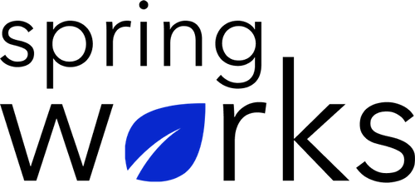
Free Template – Professional Development Survey

Use this survey to create better growth & development opportunities at work.

An employee professional development survey is essential in analyzing the roles, performance, and interest in their job responsibilities. Copy this template to your Google Drive and customize it for your organization.

Communication (to be added as review instructions):

Your responses to this survey are anonymous. The leaders are committed to analyzing your results and taking action. Please answer this quick survey by <HOUR OF THE DAY> on <DATE>.

Thank you for your time. Your responses will help our organization become a better place to work. If you have any questions about the survey, please contact [insert name of contact person].

Demographic Information:

The following information is requested so that meaningful analysis and comparisons of group results can be made. Please check the circle corresponding to your answer.

Q: Your Gender:

- Male
- Female

Q: Your Department:

- Marketing
- Operations
- Tech
- Accounting
- HR

Q: Company Service:

- Under 1 Year
- 1-2 Year
- 3-5 Year
- 6-10 Year
- 10-15 Year
Professional Development Questionnaire

To answer clearly what you think or feel about each item, please follow these steps:

- Read each item fully before you start to mark your answer.
- Pick the one answer which most nearly says what you think or how you feel.
- While completing the questions, be sure to read the special instructions which are included.

Choose the most appropriate answer:

Q: Are you interested in professional development activities?

- Yes
- No

Q: I am satisfied with the career advancement option offered to me.

- Strongly agree
- Agree
- Neutral
- Disagree
- Strongly disagree

Q: Does the organization invest in the training of employees?

- Yes
- No

Q: Have you devoted time to professional development in the past?

- Yes
- No

Q: I have the opportunities to apply my expertise and skills.

- Strongly agree
- Agree
- Neutral
- Disagree
- Strongly disagree

Q: Employees receive regular development through workshops:

- Strongly agree
- Agree
- Neutral
- Disagree
- Strongly disagree

Q: The manager supports career development plans:

- Strongly agree
- Agree
- Neutral
- Disagree
- Strongly disagree

Q: How well does our organization support you in exploring your professional interests and goals?

- Extremely supportive
- Somewhat supportive
- Neutral
- Somewhat unsupportive
- Extremely unsupportive

Q: I am satisfied with my chances for promotion:

- Strongly agree
- Agree
- Neutral
- Disagree
- Strongly disagree

Q: I am satisfied with the investment my organization makes in training and education:

- Strongly agree
- Agree
- Neutral
- Disagree
- Strongly disagree

Q: Do you have a mentor at work?

- Yes
- No

Q: I am satisfied with continuing professional development opportunities available to me in my current role:

- Strongly agree
- Agree
- Neutral
- Disagree
- Strongly disagree

Based on the efforts put in your learning and development, how likely are you to recommend our company to your family and friends?

0 | 1 | 2 | 3 | 4 | 5 | 6 | 7 | 8 | 9 | 10

Q: In terms of training and professional development, what would you like to see us offer or continue to offer?

Q: What additional training or education would help you better do your job?

Q: Which department at our organization would you like to learn more about?

Thanks for your responses!

